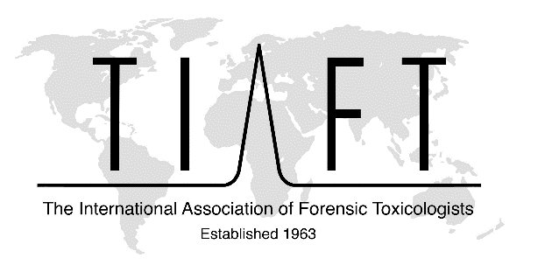

ALAN CURRY AWARD - Nomination form
Please insert the name of the TIAFT member being nominated:
Please insert your name as the nominating TIAFT member:
Date:

Information about the nominee:
The number of years the nominee has been a TIAFT Member:
Date of Joining TIAFT:
Please list main contributions to analytical and forensic toxicology:

What is the nominees Hirsch index?
List their 5 most important publications (peer-reviewed articles or books):

Please list their significant contributions to TIAFT:

If known, please share the number of TIAFT annual meetings the nominee has attended:

Please list other special considerations in support of the nomination:

Please list peer-reviewed Pubmed-listed papers:

Appendices (if any, e.g. CV of the nominee, LinkedIn profile etc.):

