INTERLABORATORY COMPARISON ON THE DETERMINATION OF CANNABINOIDS: SPIKED SERUM VERSUS A "REAL" BLOOD SPECIMEN (GTFCH FORENSIC TOXICOLOGY RING-TESTS)
R. E. Aderjan, M. Herbold
Institute of Legal Medicine and Traffic Medicine, Voßstraße 2, D 69115 Heidelberg

In Germany (and in Belgium, too), driving under influence of drugs is sanctioned according legal regulations requesting the analysis of serum or blood samples. As a rule, the violation consists in the presence of the active principle of the drug like THC while driving. However, for drugs with unstable parent compounds and in order to show the analytical plausibility, definite relevant drug metabolites need to be determined instead and as well, respectively. Consequently, labs performing drug determination are subject to external quality control referring to the substances whose presence has to be proven.
Recently, we observed that even experienced labs found considerably different concentrations of Delta-9-carboxy-THC (THCCOOH) in serum samples of drivers under Cannabis influence. By own investigations aiming at clarifying these discrepancies we could show, that a phase II metabolite of THC, the acid-labile THCCOOH-Glucuronide might contribute to the analytical result. If THCCOOH is liberated from its glucuronide during cannabinoids extraction, false positive concentration measurements will be obtained. (M. Mauden, G. Skopp, R. Mattern und R. Aderjan (2000) Blutalkohol 37: 48 – 56)
To give labs information on the reliability of their cannabinoid extraction procedures for serum samples, in addition to spiked samples without the (expensive) critical metabolite, we introduced a real sample ring test into the GTFCh external quality assessment programme. We organised two such ring tests up to date. The figure below shows important results obtained in one of them.

THCCOOH serum concentration determined with GC/MS
and different extraction procedures in a “real” ring test specimen
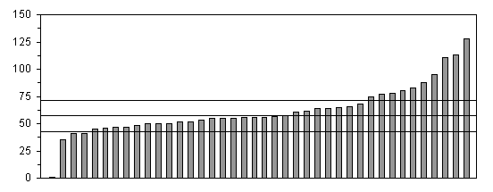
Distribution of results of 40 Labs

The comparison of values which individual labs obtained from a spiked and a real sample shows that there are labs which may need to adjust their extraction procedure in order to avoid false positive determination of unconjugated THCCOOH.
Our results show that future ring tests need not only to aim at precise and accurate analytical results but also to more closeness to reality. The relevance of differentiation between conjugated and unconjugated metabolites as well as the ethical consequences resulting for an external quality control scheme when sampling of real drugged specimen will be discussed.
Keywords: Driving under influence; Cannabinoids; Blood analysis; Proficiency testing
(rolf_aderjan@med.uni-heidelberg.de)

